Build PyTorch Neural Networks

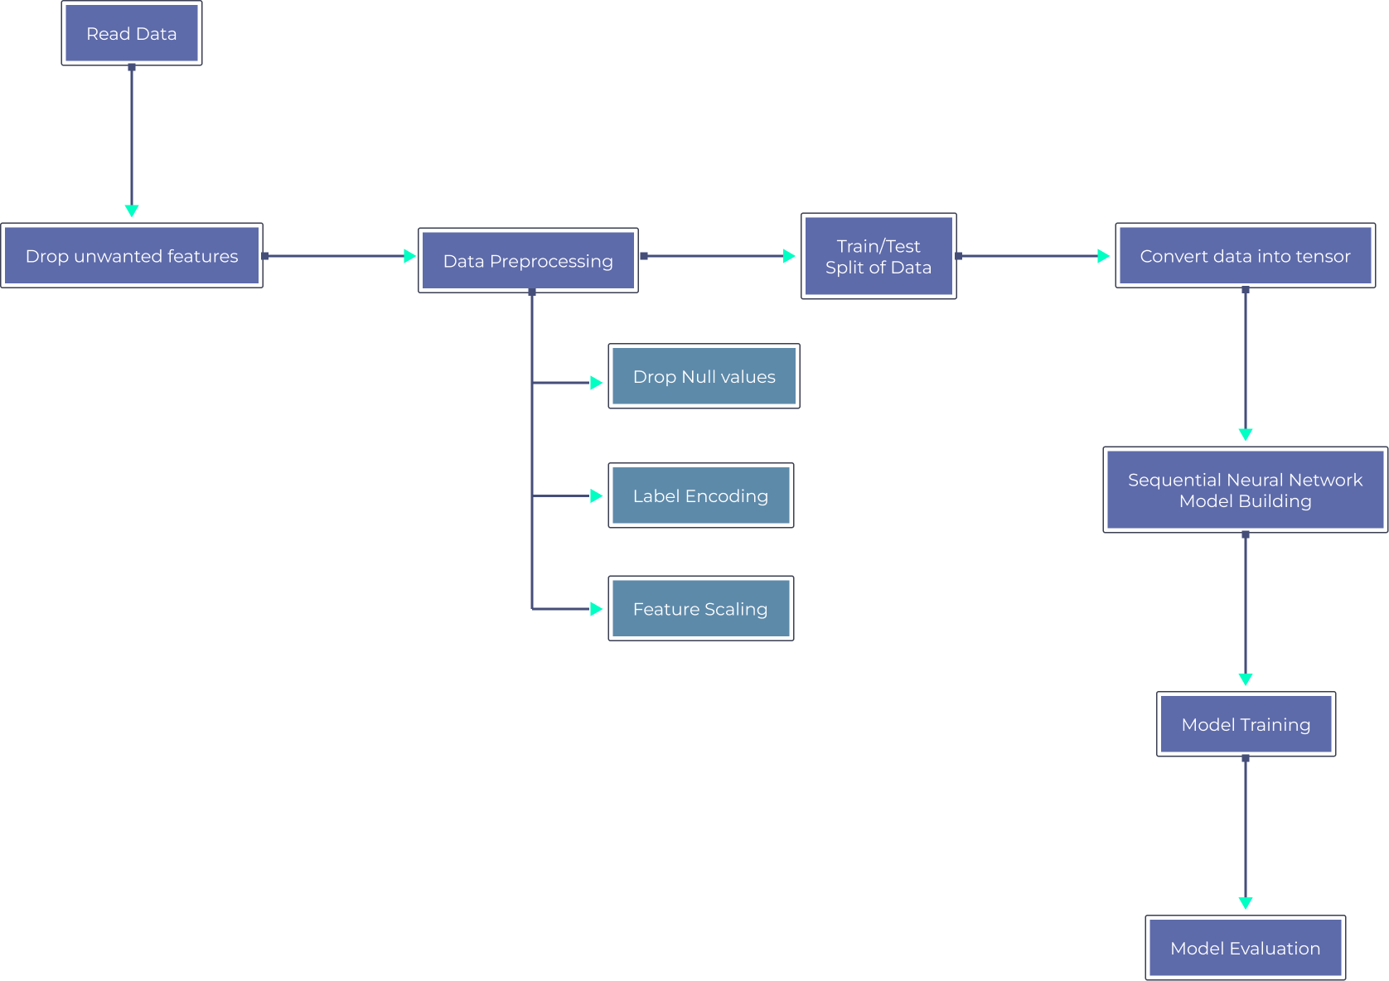
Overview
Neural Networks are a set of algorithms inspired by the human brain and form the foundation of deep learning. PyTorch is a popular deep learning framework that makes building neural networks simple and intuitive. Neural networks can solve business problems such as classification, text recognition, and image segmentation.
This demonstrates how to build them sequentially in PyTorch for a customer churn classification problem.
Aim
- Classify customer churn using a neural network built with PyTorch
Data Description
The dataset contains customer churn information with:
- 2000 rows
- 15 features
- Target variable: Churn
Tech Stack
Language:
- Python
Libraries:
- Pandas
- PyTorch
- Matplotlib
- Scikit-Learn
- NumPy
Approach
1. Data Cleaning
2. Data Preprocessing
3. Building a Sequential Neural Network
4. Model Training
Modular Code Overview
Project Structure:
Input/
data.csv
Notebook/
Project Notebook.ipynb
src/
ML_pipeline/
Engine.py
requirements.txt
Readme.md
Folder Description:
1. Input Folder
- Contains the dataset used for analysis.
2. Notebook Folder
- Contains the Jupyter Notebook version of the project.
3. src Folder
- Contains all modularized code.
- Includes:
- ML_pipeline
- Engine.py
4. requirements.txt
- Contains required libraries and versions.
- Install using:
pip install -r requirements.txt
5. Readme.md
- Contains instructions for running the project.

